===== Training Summary =====

Best validation epoch: 488

Best validation total loss: 0.347015

Last-epoch (Train):

total: 0.345339

mse: 0.026063

mae: 0.116066

ssim: 0.495188

edge: 0.416779

l1_sparse: 0.562013

kl_sparse: 0.425613

Last-epoch (Val):

total: 0.347016

mse: 0.026560

mae: 0.116577

ssim: 0.497491

edge: 0.415746

l1_sparse: 0.568058

kl_sparse: 0.423315

Validation PSNR: 21.78 dB

Validation SSIM: 0.5025

Latent dim: 512, Total params: 554,533

Loss weights -> MSE:1.0, MAE:0.25, SSIM:0.5, EDGE:0.1, L1:0.001, KL:0.001 (rho=0.05)

Saved latent vector to latents/latent_vector.csv

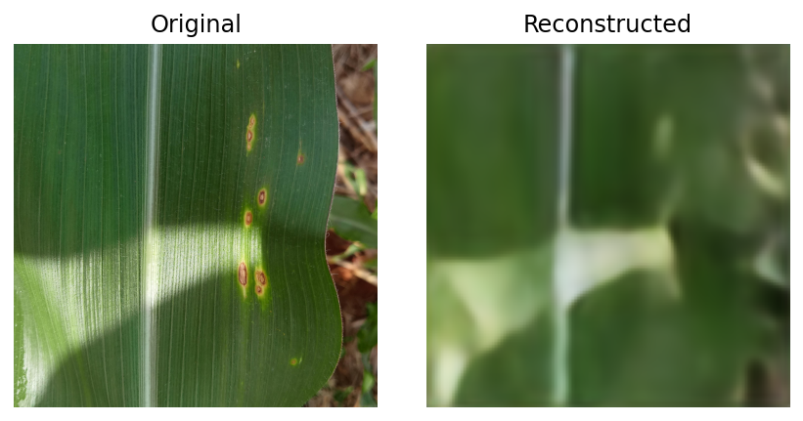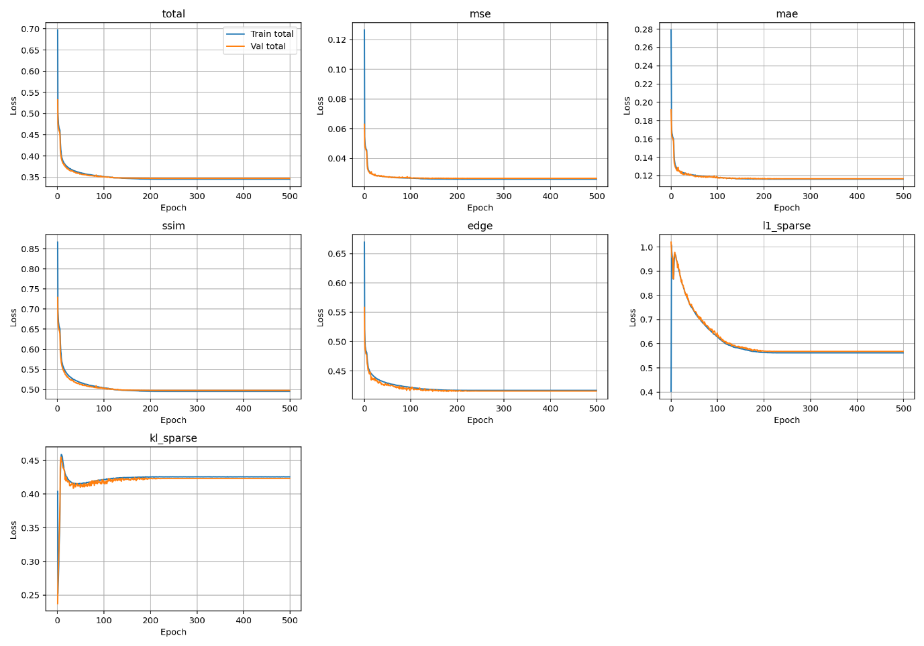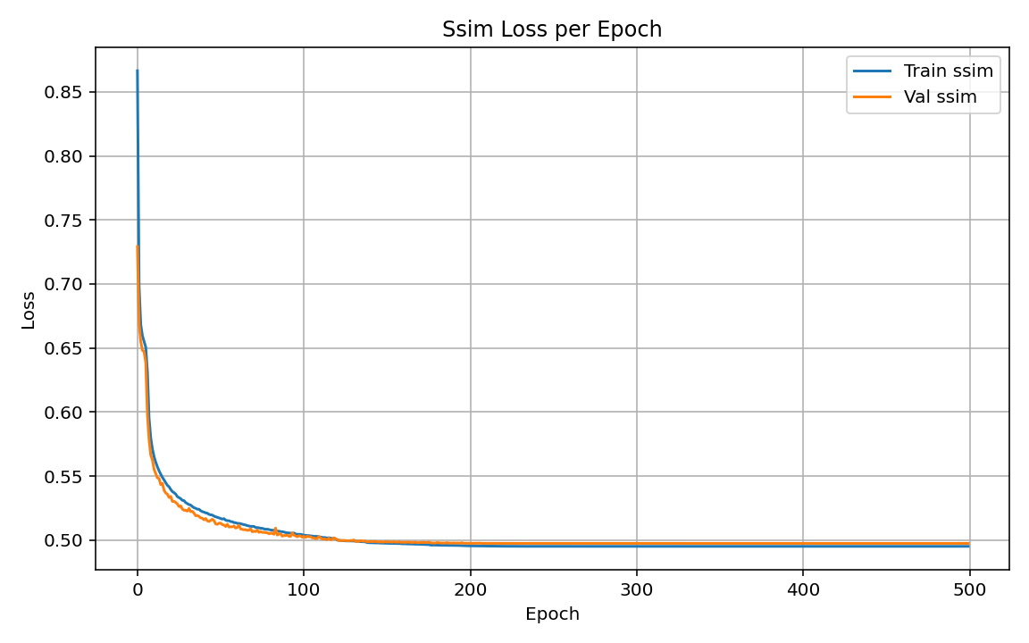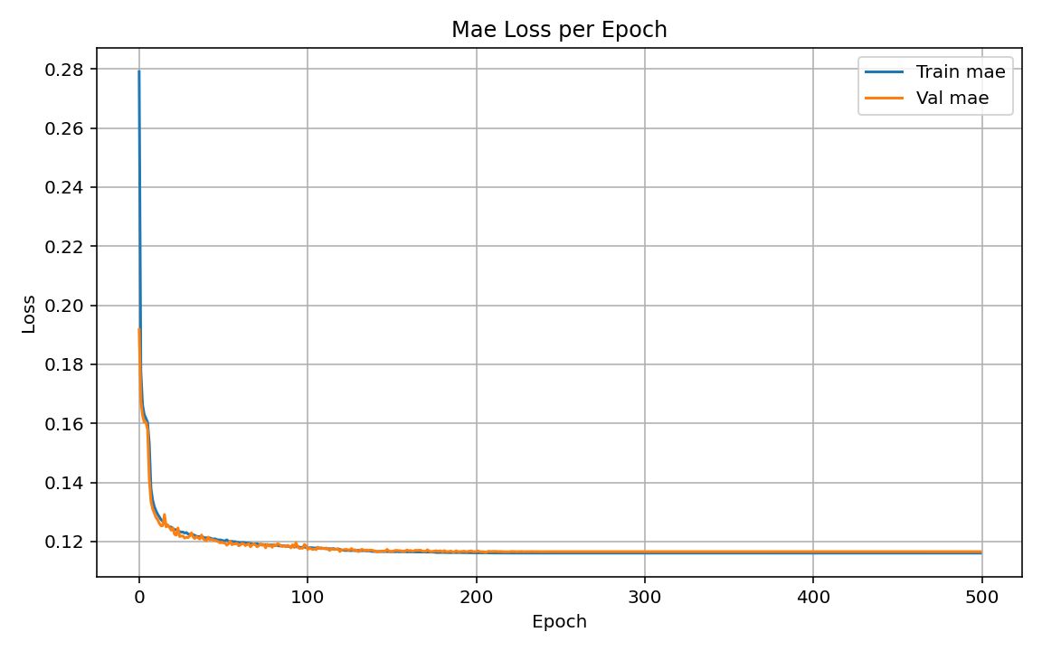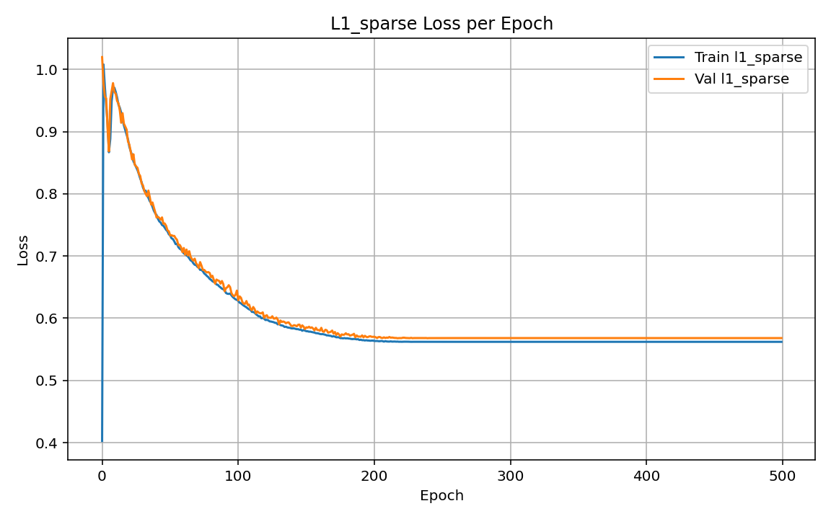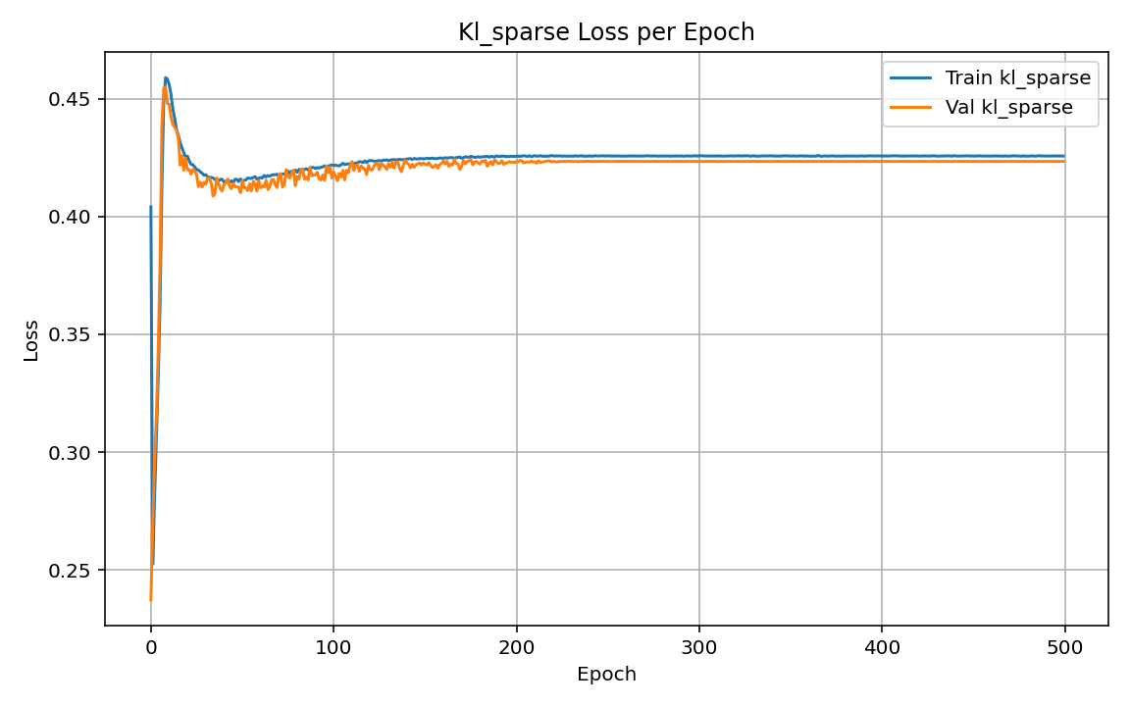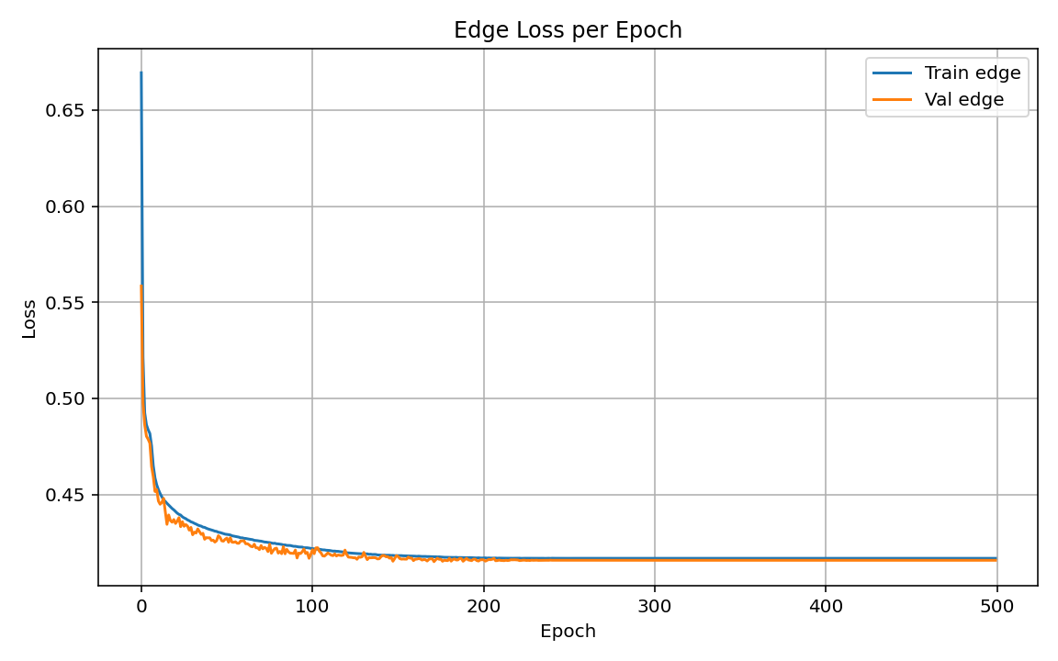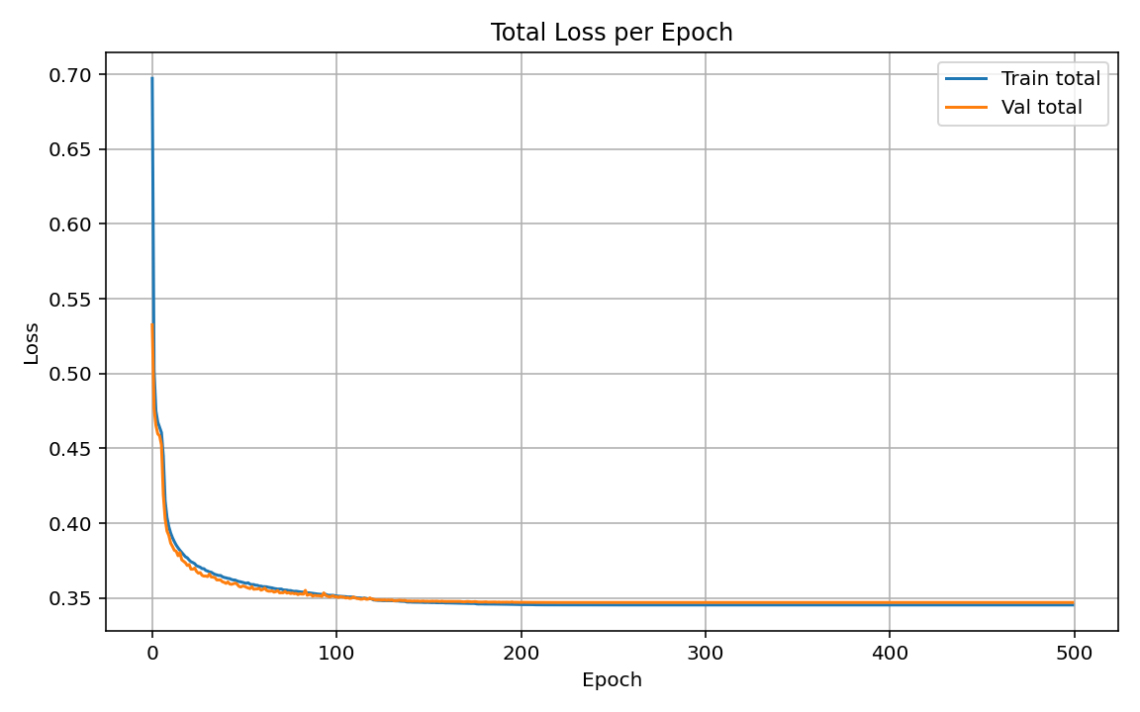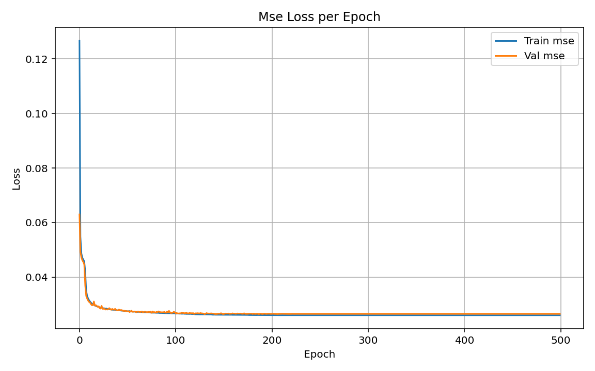

===== Training Summary for 1024 vector =====

Best validation epoch: 475

Best validation total loss: 0.270492

Last-epoch (Train):

total: 0.269876

mse: 0.017002

mae: 0.092147

ssim: 0.384570

edge: 0.365886

l1_sparse: 0.542686

kl_sparse: 0.421548

Last-epoch (Val):

total: 0.270493

mse: 0.017207

mae: 0.092122

ssim: 0.385659

edge: 0.364600

l1_sparse: 0.542542

kl_sparse: 0.423563

Validation PSNR: 23.66 dB

Validation SSIM: 0.6143

Latent dim: 1024, Total params: 554,663

Loss weights -> MSE:1.0, MAE:0.25, SSIM:0.5, EDGE:0.1, L1:0.001, KL:0.001 (rho=0.05)

Saved latent vector to latents/latent_vector.csv

